Web Containers

Server configuration

1. Copy apache-tomcat-8.0.14-windows-x64.zip/ apache-tomcat-8.0.14-windows-x32.zip from usb drive
2. Unzip archive into your java tools folder
3. Define CATALINA_HOME environment variable in User variables. You must set it to apache-tomcat folder

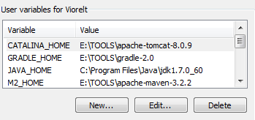

1. Add %CATALINA_HOME%\bin to User Variable PATH

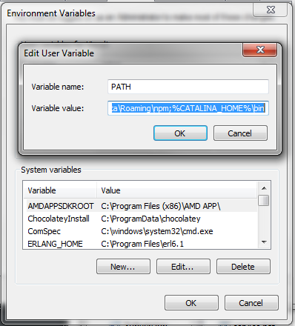

1. Add apache-tomcat as maven server. Open %M2_HOME%\conf\settings.xml file. Navigate to “servers” paragraph. By default there is no server defined in maven. To define apache tomcat add the following text in “servers” area:

<servers>

<server>

<id>local_tomcat</id>

<username>tomcat</username>

<password>tomcat</password>

</server>

<servers>

Save file.

1. Add “tomcat” user credentials to tomcat-users. To do that open %CATALINA_HOME%\conf\tomcat-users.xml and place the following text under the <tomcat-users> tag:

<role rolename="manager-gui"/>

<role rolename="manager-script"/>

<role rolename="manager-jmx"/>

<role rolename="manager-status"/>

<role rolename="admin-gui"/>

<user username="tomcat" password="tomcat" roles="manager-gui,manager-script,manager-jmx,manager-status,admin-gui"/>

Save file.

1. Open CMD and run command catalina jpda run

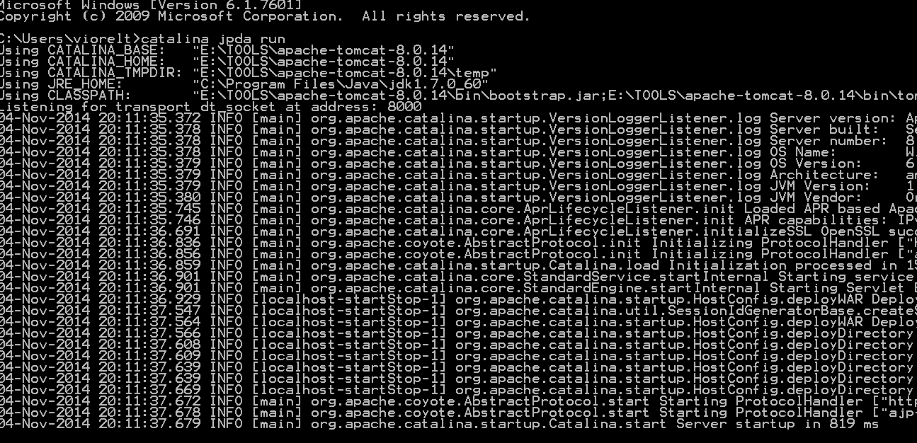

1. Open github <https://github.com/ZeroToHero-2014/JEE> repository and fork-it to your user



1. Navigate to the forked version and clone it to your local projects workspace.
2. Open the cloned project into IntelliJ IDEA
3. Run maven clean install
4. Run maven tomcat:deploy-only under the tomcat plugin
5. Open IntelliJ IDEA Settings  navigate to Plugins, click Browse repositories… button and search for RemoteSynchronizer plugin. Click Install plugin button , Ok and Restart button if appears. If it not appears then you must restart IntelliJ IDEA manually.
6. Open IntelliJ IDEA Settings  navigate to Remote Synchronizer plugin

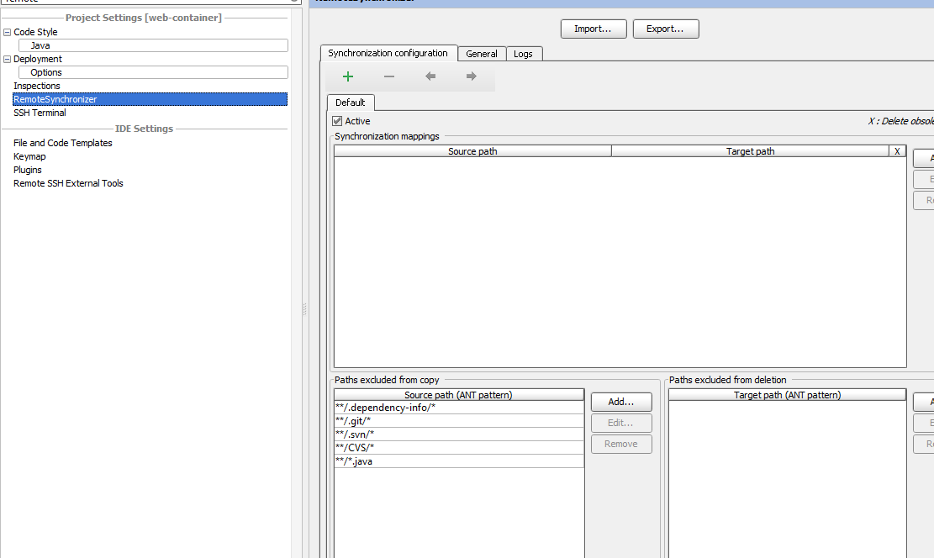

Click Add button and in the Source path you must select the path to your webapp folder from the current project; in the Target path you must select %CATALINA_HOME%\webapps\web-container and press Ok.